

Commercial Solar PV Case Study

Project Details
Location: Exploration Drive, Leicester LE4 5JU. Install timeline: February 2021 – April 2024. Systems: Dock 2 (28.5kWp), Dock 3 (66kWp), Dock 4 (73kWp). Each installation completed within 2 weeks.

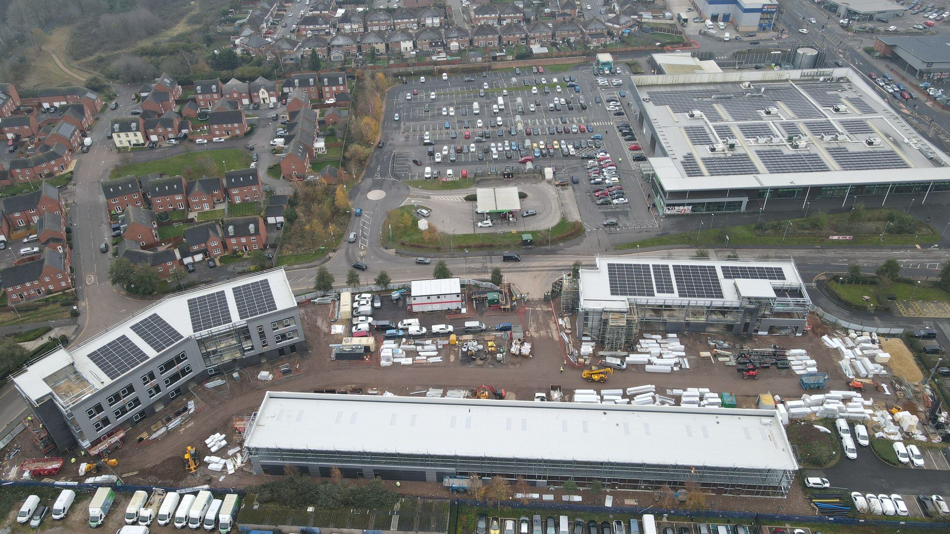
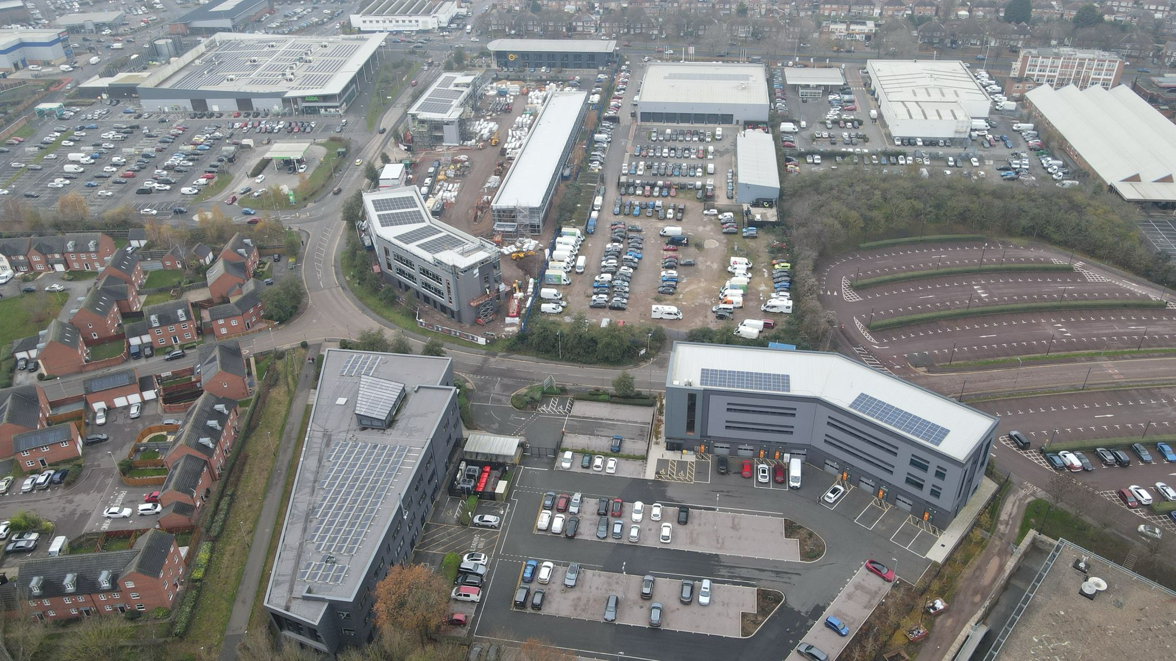

About Synergy Power
Founded in 2012, Synergy Power Ltd has over 12 years of experience delivering high-quality solar PV installations across the UK. The company is committed to creating carbon-neutral environments and supporting the UK’s transition to a cleaner, more sustainable future. With a strong focus on customer satisfaction, bespoke design, and long-term performance, Synergy Power has built a reputation for delivering reliable, high-performance renewable energy systems.

Client Background
The client operates a busy multi-dock commercial facility located in Leicester, supporting logistics and industrial operations. Energy consumption across the site is significant, driven by operational equipment, lighting demands, and long working hours. With rising energy costs and increasing pressure to improve sustainability, the client sought a long-term renewable energy solution that would reduce operational expenditure while aligning with environmental goals and carbon reduction targets.

The Challenge
This project required a phased installation across three separate dock buildings over a three-year period. Each installation had to be carefully scheduled to avoid disruption to daily operations. Structural assessments were required to ensure each roof could support solar arrays, while electrical integration needed to remain consistent across installations delivered years apart. Additionally, differing system sizes and evolving technology across the timeframe created challenges in maintaining design continuity and performance optimisation.

The Solution
Synergy Power designed and delivered three bespoke solar PV systems tailored to each dock's specific requirements. The installations were strategically phased, enabling the client to spread investment while progressively increasing renewable generation capacity. High-efficiency solar panels and industry-leading inverter technology were selected to ensure long-term reliability, efficiency, and return on investment. A trapezoidal direct fix mounting system was used across all installations to provide a secure and durable solution.

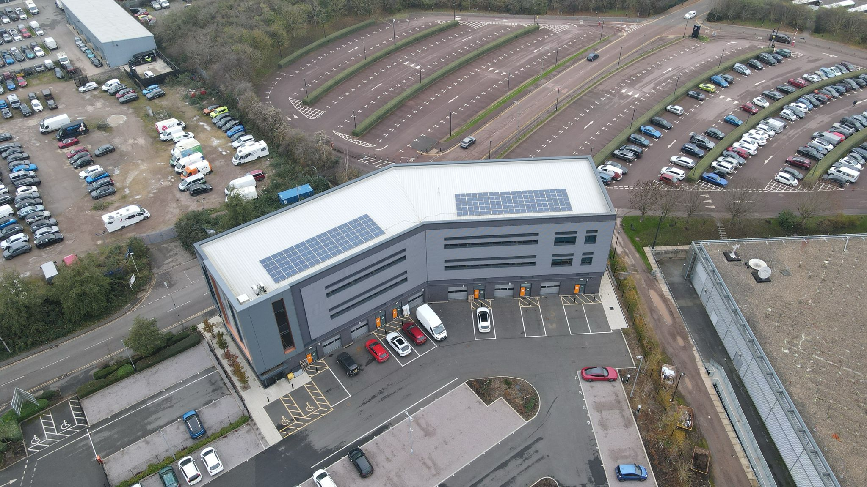

Key Design Considerations
Detailed structural surveys ensured roof compatibility and safe load distribution. Panel positioning was carefully optimised for maximum solar exposure and generation efficiency. Inverter selection ensured system compatibility, scalability, and monitoring capabilities. Future-proofing was a core consideration, ensuring that each phase of installation could be seamlessly integrated and expanded upon.

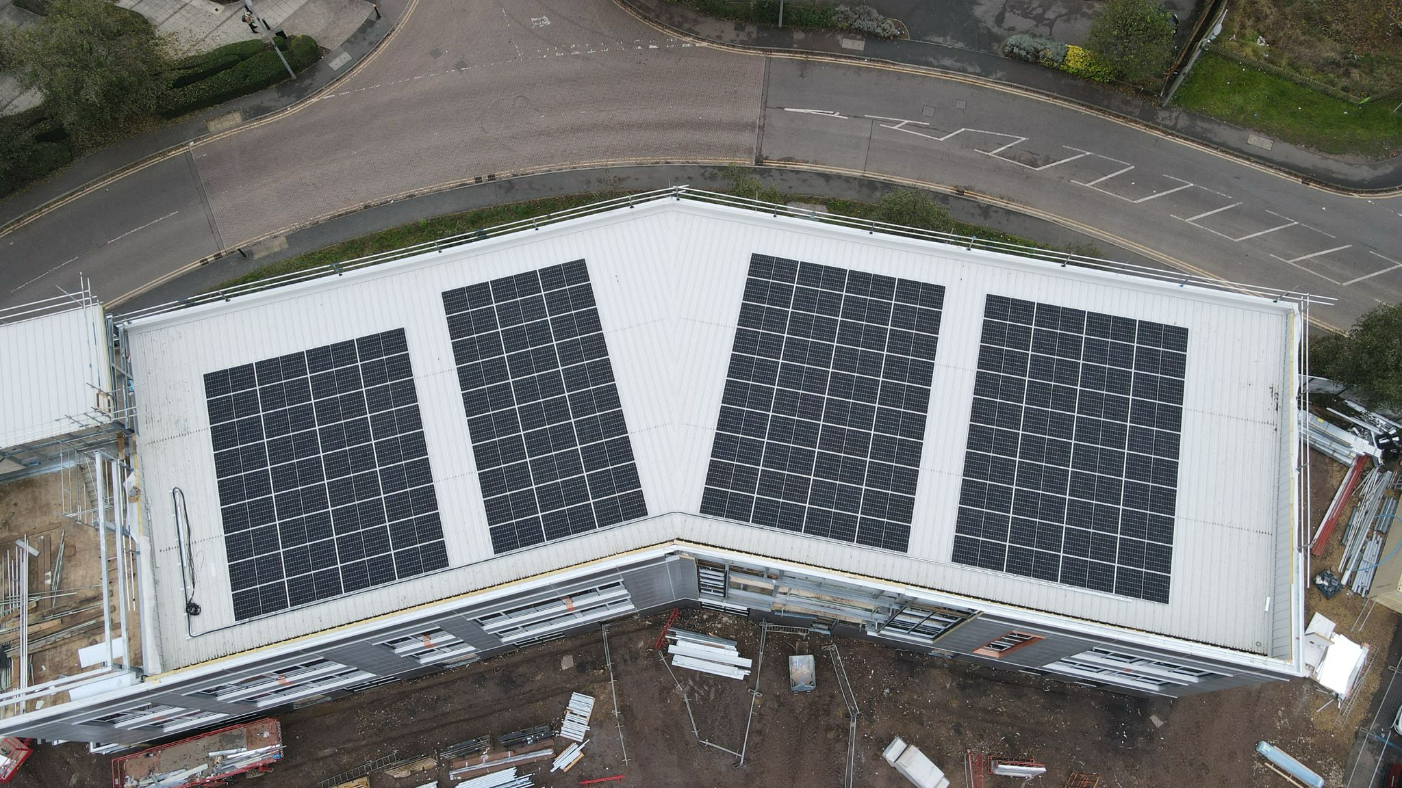

System Specifications
Dock 2: 28.5kWp system comprising 100 x 285W Trina solar panels and a 25kW Growatt 3-phase inverter (installed February 2021). Dock 3: 66kWp system with 132 x 500W JA Solar panels and a 60kW Solis 3-phase inverter (installed April 2024). Dock 4: 73kWp system with 146 x 500W JA Solar panels and a 60kW Solis 3-phase inverter (installed April 2024). All systems were installed using a trapezoidal direct fix mounting system.

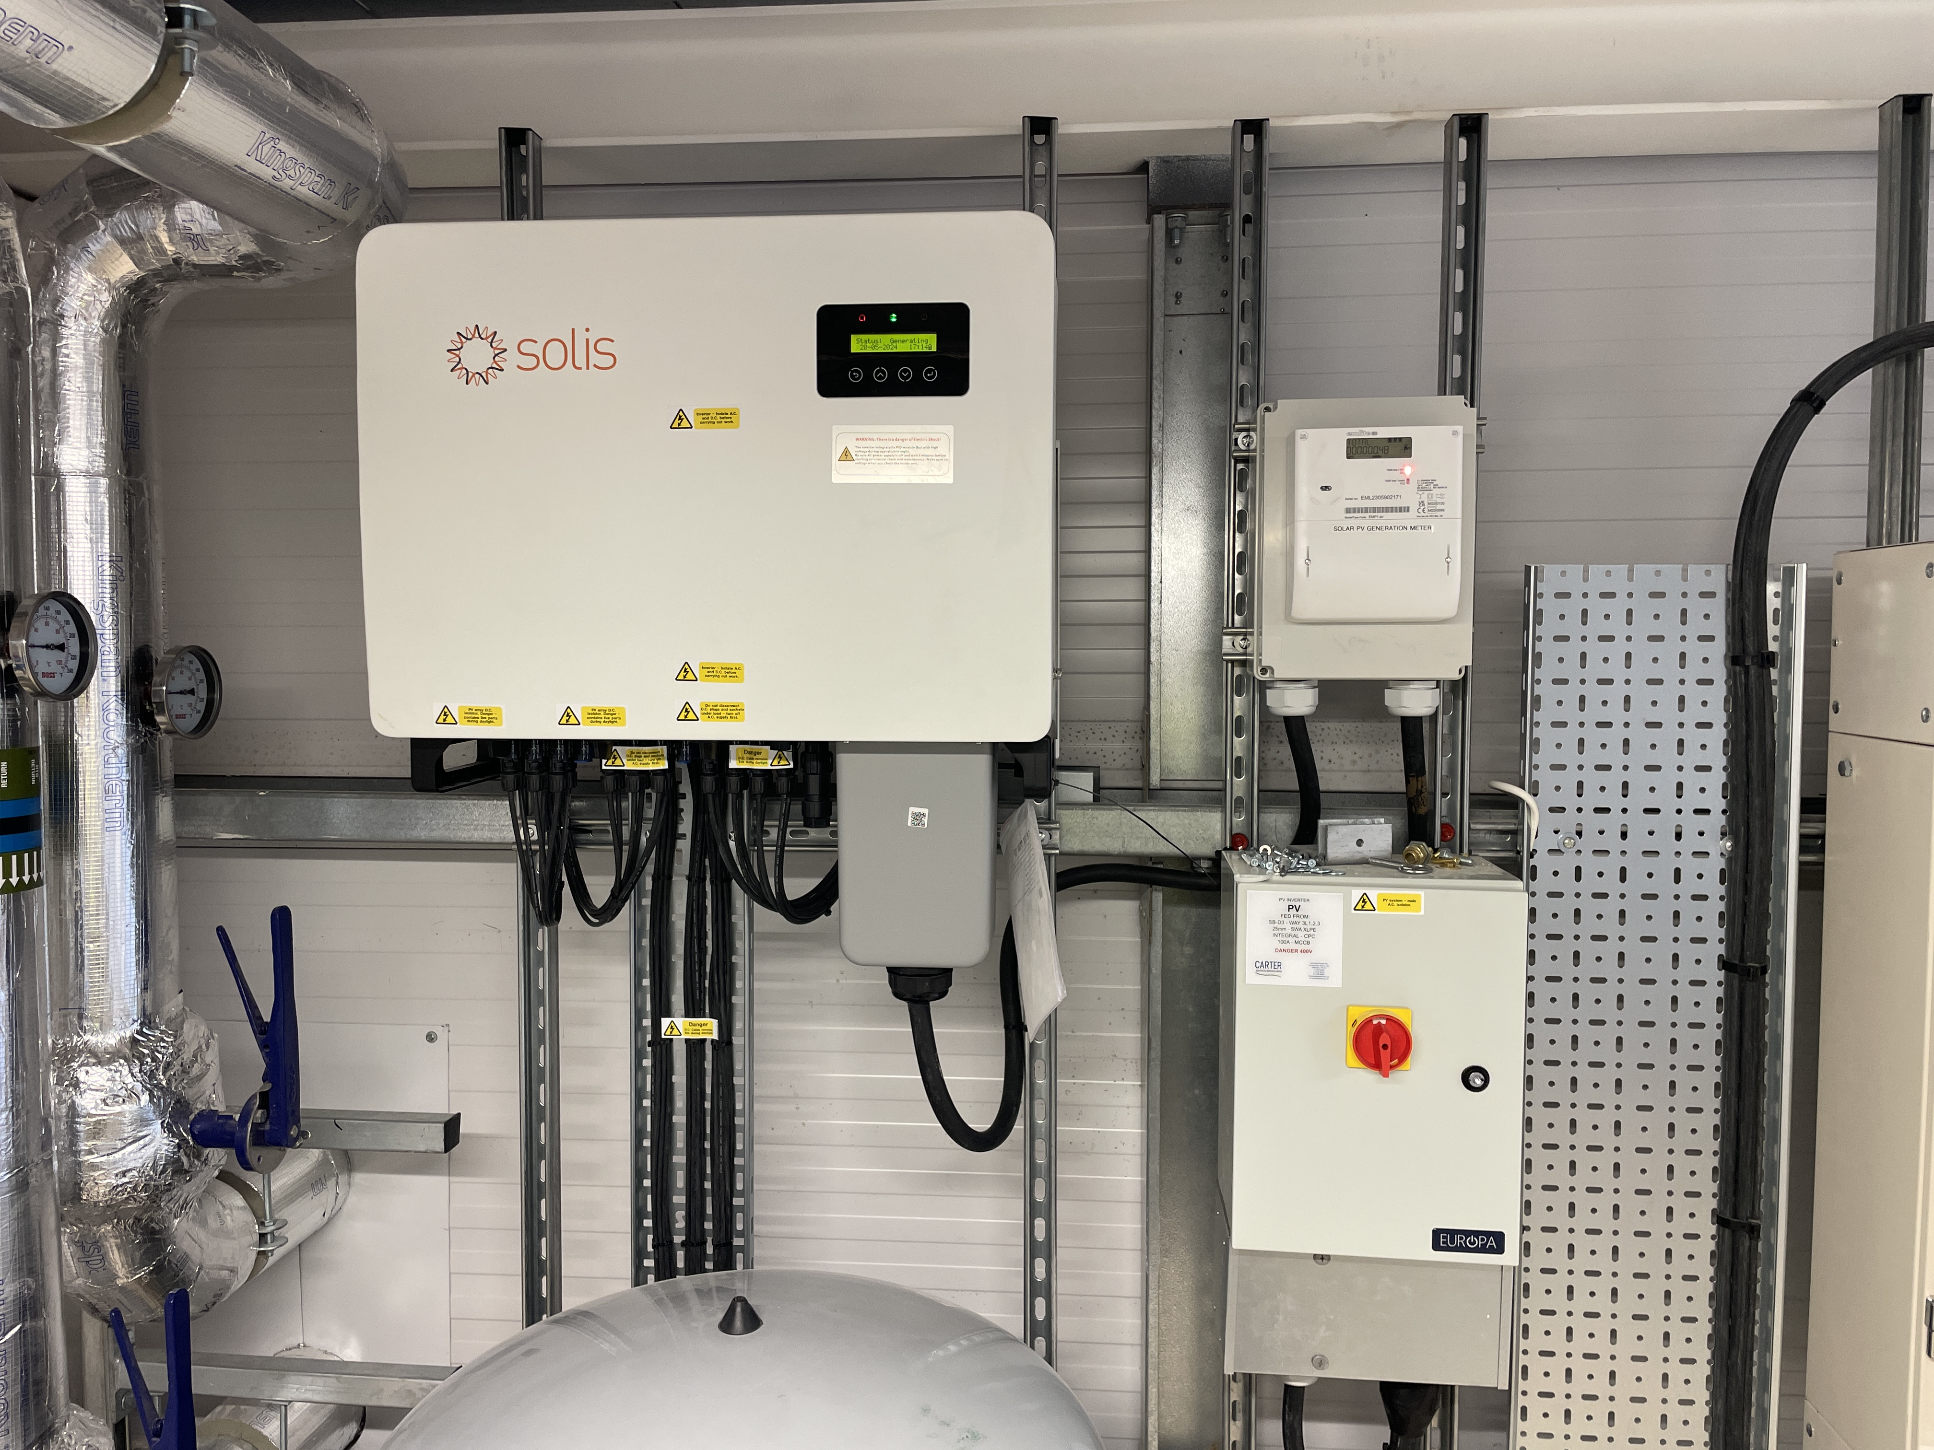

Installation Process
Each installation was completed within a two-week programme. The process included detailed planning, safe installation of the mounting system, panel fixing, inverter connection, and full electrical integration. Each system underwent rigorous testing and commissioning to ensure optimal performance and compliance with industry standards. Careful coordination ensured no disruption to site operations.

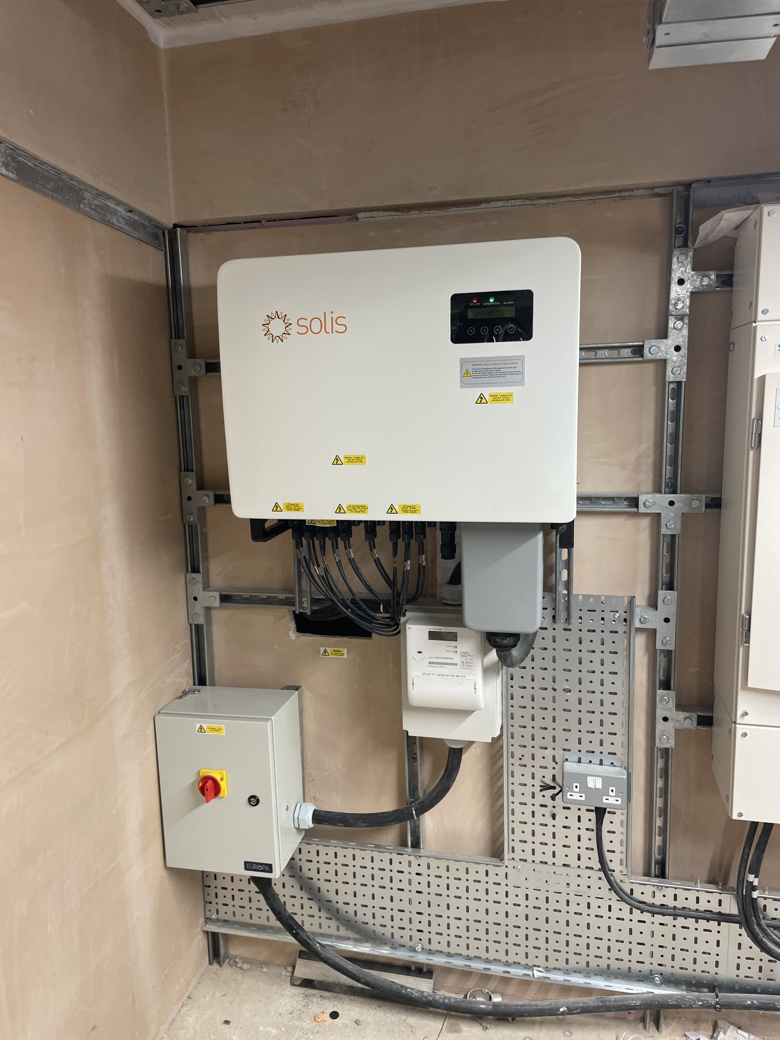

Results and Performance
The completed installations deliver significant renewable energy generation across the site, reducing reliance on grid electricity and improving overall energy efficiency. The systems are performing in line with expectations, offering consistent output and measurable cost savings. The client has seen immediate benefits in reduced electricity bills and improved sustainability metrics.

Estimated Energy Generation
Based on UK average of ~900 kWh per kWp/year:
Dock 2 (28.5 kWp): approx 25,650 kWh/year
Dock 3 (66 kWp): approx 59,400 kWh/year
Dock 4 (73 kWp): approx 65,700 kWh/year
Total Estimated Generation: approx 150,750 kWh per year
This equates to significant carbon reduction and long-term energy savings for the client.

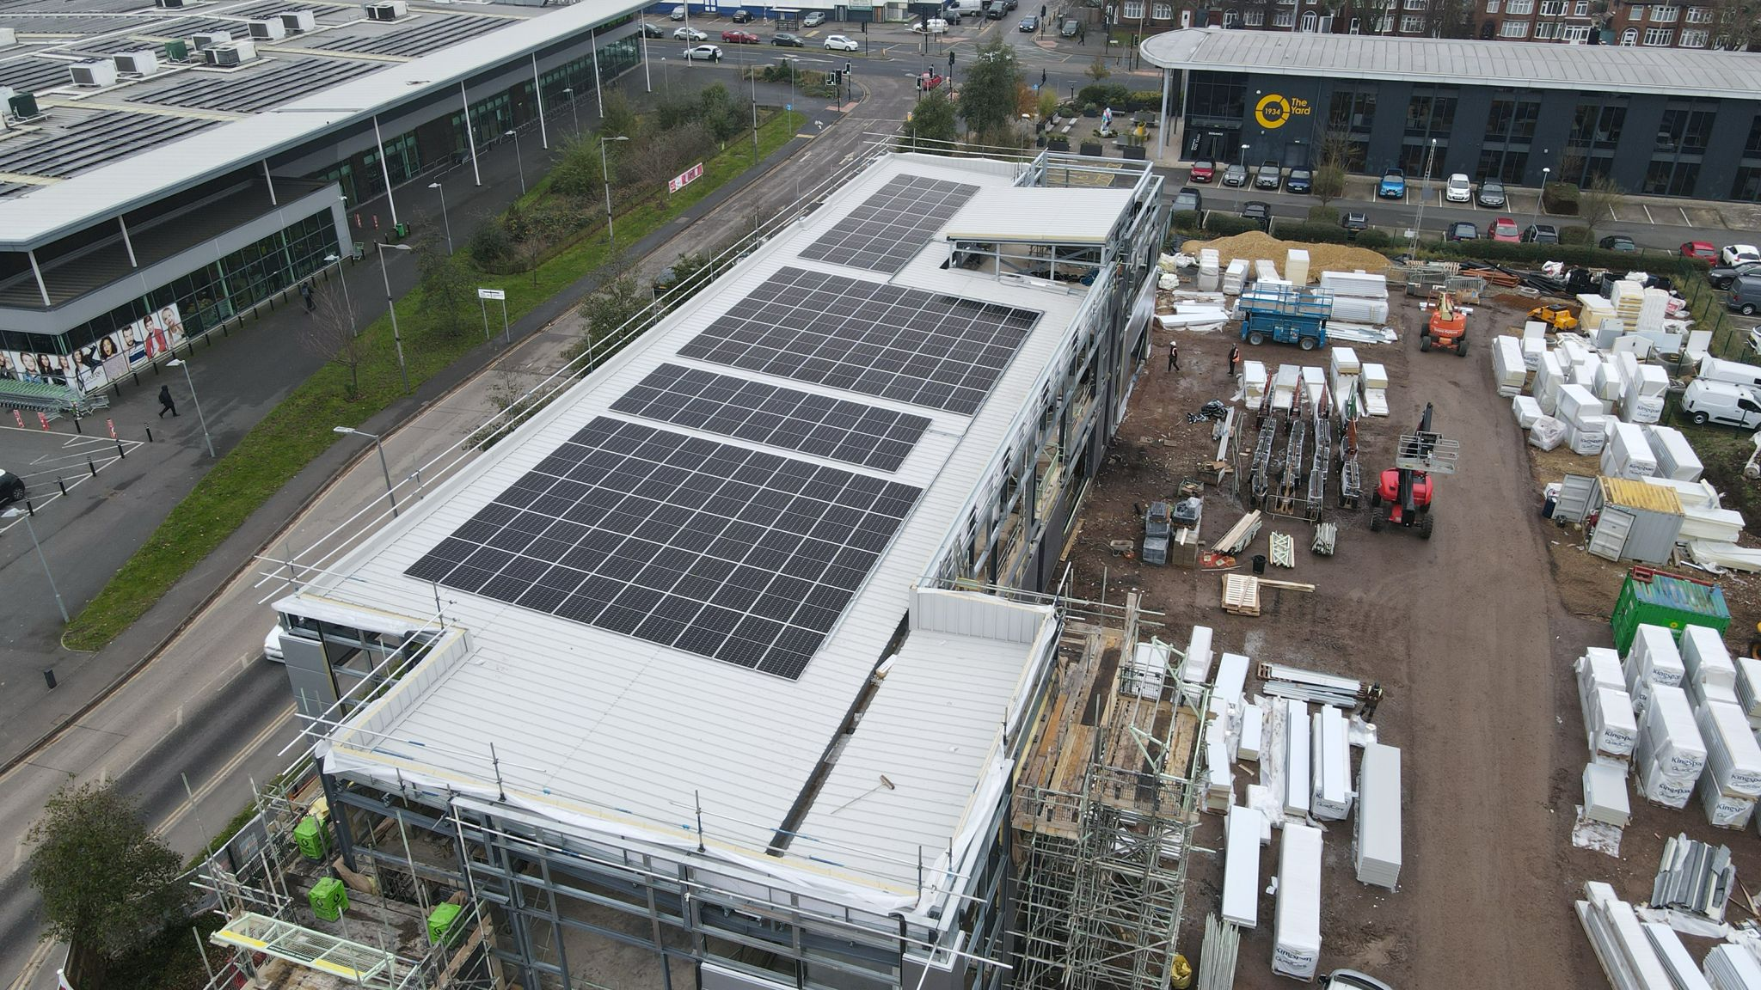

Key Outcomes
Successful delivery of three installations over a phased timeline, increased on-site renewable generation capacity, reduced operating costs, and improved environmental performance.

Key Benefits
Reduced electricity costs, protection against energy price volatility, enhanced sustainability credentials, improved asset value, and long-term return on investment.

Conclusion
This project highlights Synergy Power’s expertise in delivering complex, phased commercial solar installations. Through careful planning, technical excellence, and a customer-focused approach, Synergy Power has provided a scalable renewable energy solution that meets both current and future energy demands.

Accreditations & Certifications

