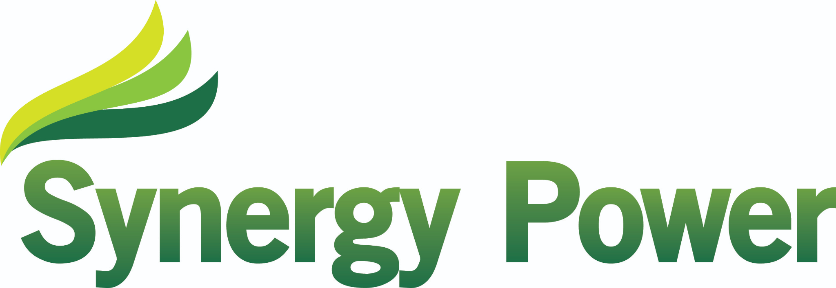

SOLAR PV PROJECT CASE STUDY

Little Owls Nursery – Leeds Council

110kWp Commercial Solar Installation | Completed March 2023

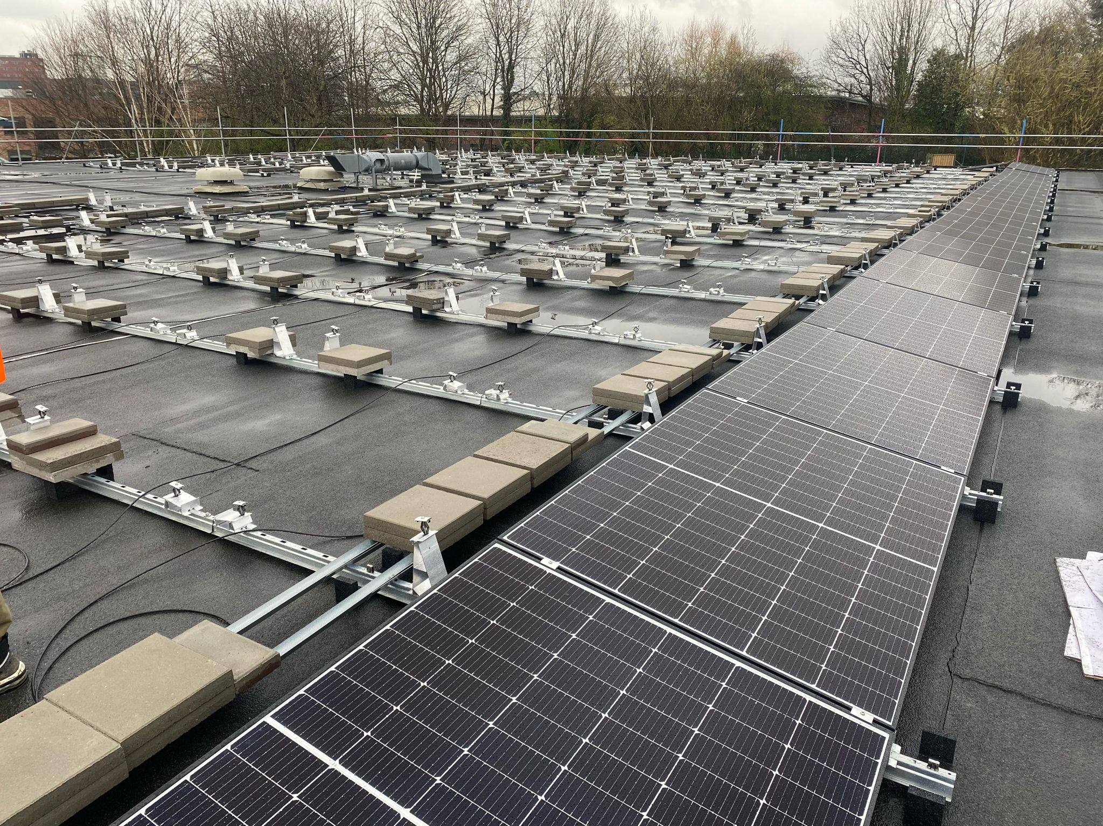

Client Background
Little Owls Nursery, operated by Leeds City Council, plays a vital role in delivering early years education services within the Chapel Town community. As part of Leeds City Council’s wider environmental and sustainability strategy, the organisation is committed to reducing carbon emissions, improving energy efficiency, and lowering operational costs across its estate. With consistent daytime energy consumption driven by lighting, heating, kitchen use and education facilities, the site presented an excellent opportunity to maximise the benefits of solar photovoltaic technology.

The Challenge
The project presented a number of engineering and operational challenges. The flat roof structure required a non-penetrative mounting solution that would not impact the building fabric whilst still meeting strict structural loading and wind uplift requirements. Access and safety were also critical, as the nursery remained operational throughout the installation. Careful planning was required to minimise disruption and maintain a safe working environment for staff and children.

The Solution
Synergy Power designed and installed a bespoke 110kWp solar PV system, carefully tailored to the site’s requirements. The system utilises high-efficiency Canadian Solar 410W panels, paired with a Huawei 110kW inverter, delivering reliable performance and advanced monitoring capabilities. A Van der Valk ballasted mounting system was selected to ensure a secure and compliant installation without roof penetration, preserving the building structure while optimising solar generation.
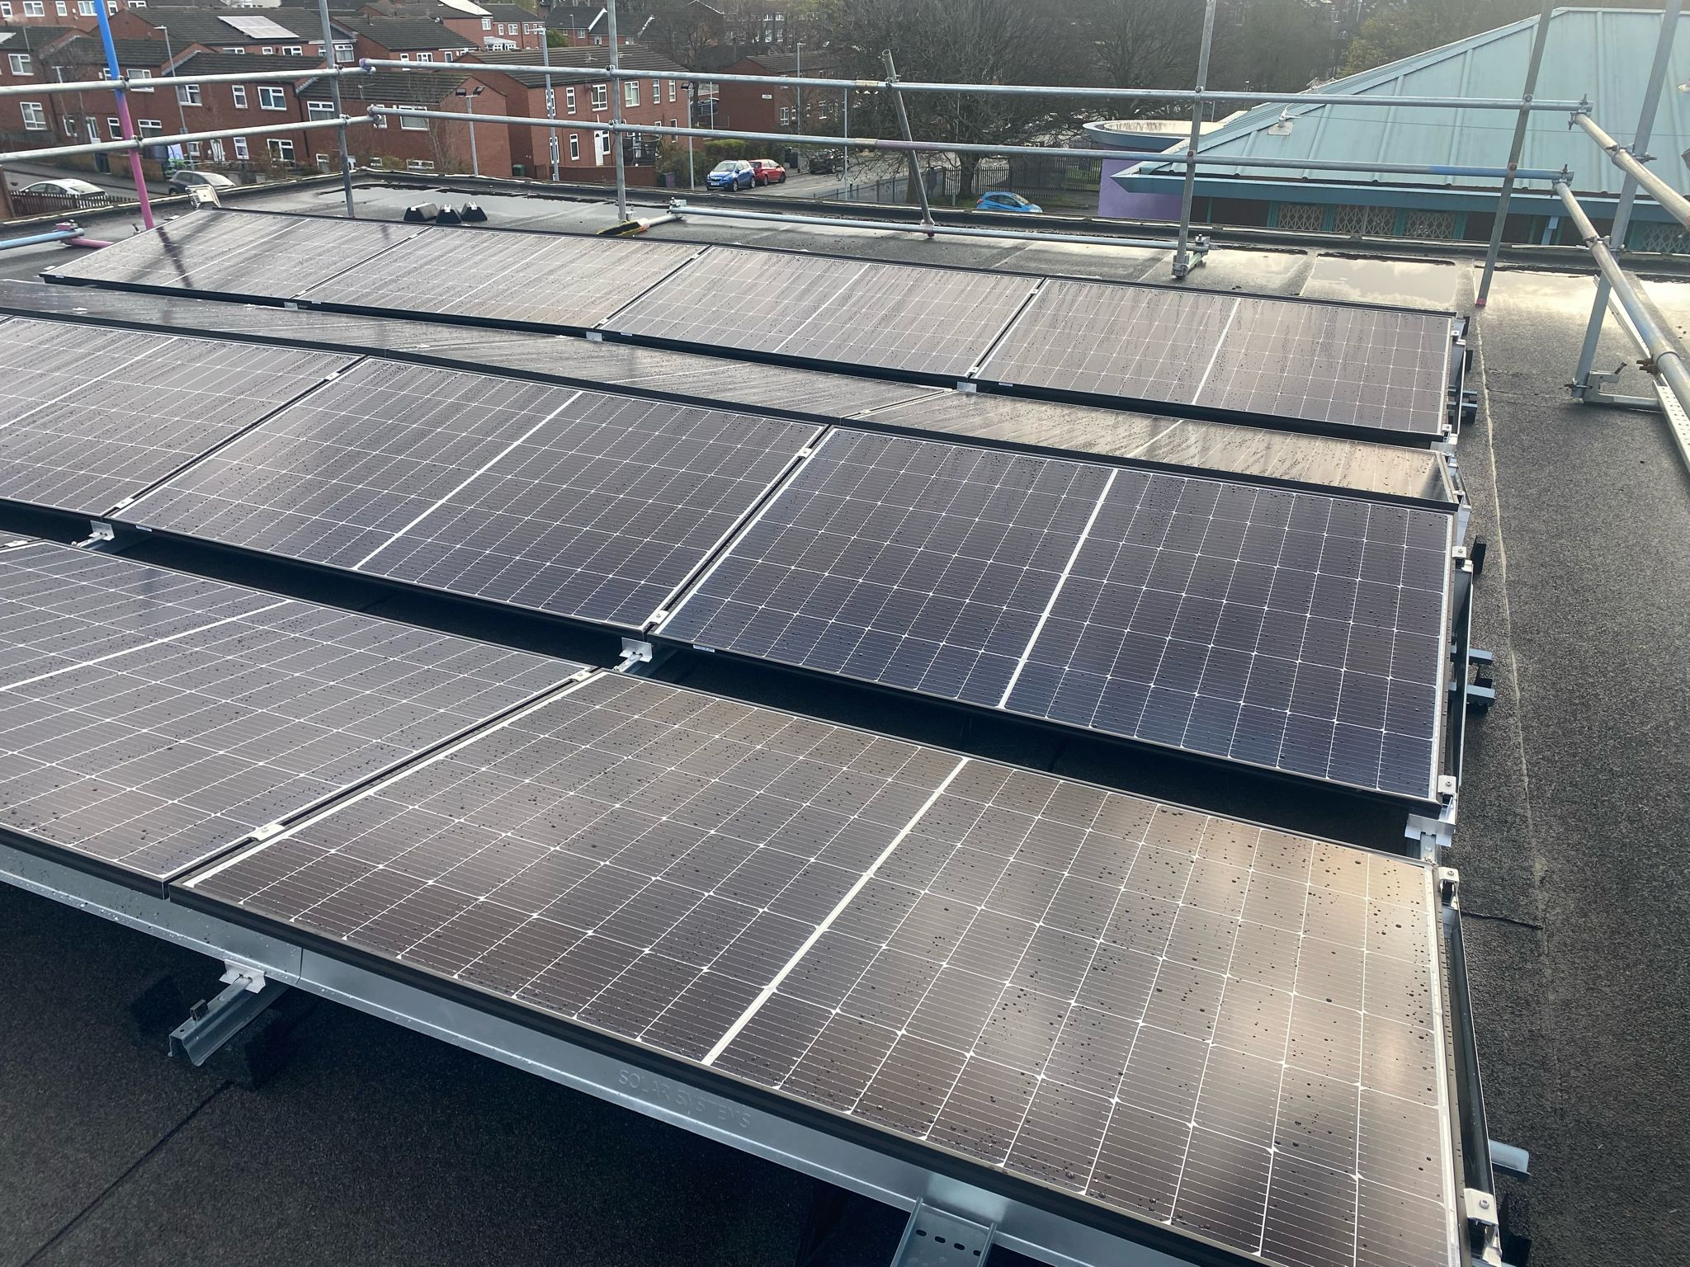

System Specifications
System Size: 110kWp
Panels: 266 x Canadian Solar 410W
Inverter: Huawei 110kW
Mounting: Van der Valk Flat Roof Ballasted System
Installation Date: March 2023
Location: Leeds, LS7 4AW

Installation Process
The project was delivered by Synergy Power’s experienced commercial installation team, adhering to strict health and safety standards. Installation began with the layout and placement of the ballasted mounting system, followed by panel installation and wiring. The inverter and electrical infrastructure were installed and fully tested before system commissioning. The project was completed efficiently, with minimal disruption to the site.
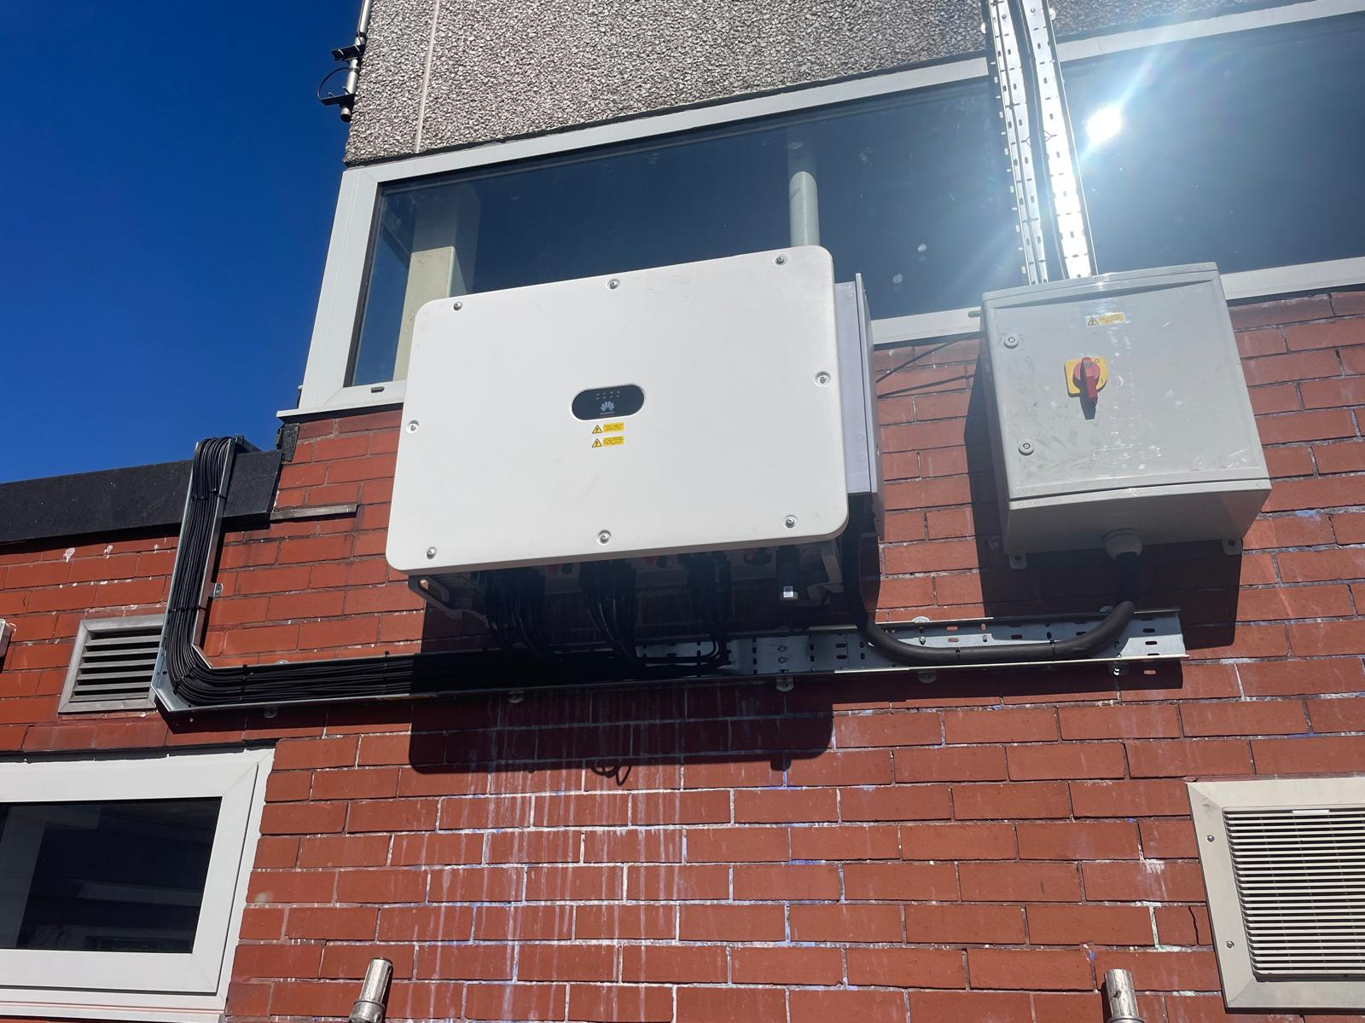

Results and Performance
The completed solar PV system provides significant renewable energy generation, directly offsetting the nursery’s electricity usage and contributing to Leeds City Council’s carbon reduction commitments. The system delivers long-term financial savings while providing a stable and sustainable energy source.

Key Outcomes
• Successfully delivered 110kWp commercial solar installation
• Reduced reliance on grid electricity
• Improved building sustainability rating
• Delivered safely and on schedule

Key Benefits
• Reduced electricity costs
• Lower carbon footprint
• High system reliability
• Long-term return on investment
• Minimal maintenance requirements

Conclusion
This project demonstrates Synergy Power’s capability in delivering complex commercial solar installations to the highest standard. By combining technical expertise, high-quality components, and a customer-focused approach, Synergy Power continues to support public sector organisations in achieving their sustainability and energy goals.

